TASK 1

INTRODUCTION TO OOP, CLASSES, AND OBJECTS

→ THEORETICAL GOALS (Read & Write in Your Own Words)

- What is Object-Oriented Programming (OOP)?
- Why is OOP important in Python and AI?
- Understand these Core Concepts:
  - Class
  - Object
  - Instance
  - Method
  - Attribute
Write 2–3 lines about each concept in your own words (not copy-pasted). This will help you build a strong foundation.

→ PRACTICAL CODING TASK

- Task 1.1: Create a Car Class
Create a class named Car with the following:
- Attributes: brand, color
- Method: display_info() to print brand and color
Create two objects of Car with different values and display their info. python

Code Example For You:
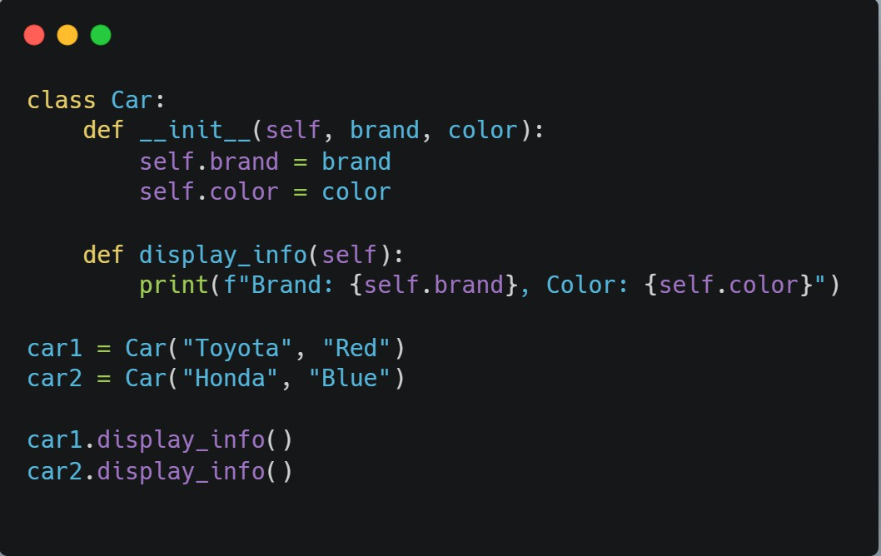

- Task 1.2: Create a Student Class
Your Own Practice:
- Class: Student
- Attributes: name, age, grade
- Method: get_details() to print student info

— † BONUS TIPS
- Type every line of code yourself don't copy-paste.
- Use # comments to explain each line in your own words.
- Draw the structure of a class and object on paper if it helps.

¸]_⬛ª DEADLINE: Complete by Today 11th May 11:59 PM

Once you complete:
- Reply "Day 1 Completed ✓⬛"
- I will send you Task 2 with a new concept!

